Chapter 19, Problem 35.

Determine the h parameters for the network in Fig.19.93.

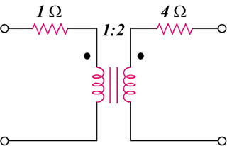

Figure 19.93
For Prob. 19.35.

